(Approx. 602 words)

Interactive Tracking Websites
By Doug Palmer, Tampa PC Users Group, FL
December 2015 issue, Bits of Blue
www.tpcug.org
dkp205 (at) hotmail.com

I have an extensive list of weird, odd and interesting websites that I've run across over the years. Here are two that might qualify as tracking maps as they track something. Most also qualify as interactive as the user has some control over the data seen.

http://raidsonline.com/
RAIDS Online is a free public crime map developed by BAIR Analytics. Crime mapping takes data available from law enforcement sources and makes it available to the public in a visual format. This is just one of several such websites available. Raids Online also has mobile apps available for Android and iPhones.

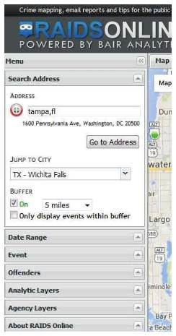
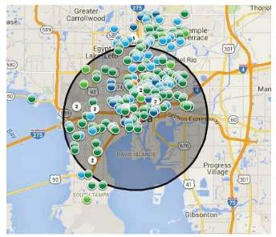
This map works much like Google Maps or other such maps on the Internet. A toolbar is on the left side of the screen that contains controls to specify multiple layers of data. At the top of the toolbar type in a city name, an address or even a zip code. The map will adjust accordingly. The Buffer section of the toolbar allows you to adjust the size of the area you wish to pinpoint. Below that are several filters that you can use to specify a date range, a long list of various events and crime to either include or exclude. Tabs on top allow you to view the data on the map, in charts or in a spreadsheet format. Once you have adjusted the area and events to your liking, you can create a daily or weekly email alert notification of crimes within a certain distance of your home or business.

http://www.marinetraffic.com/
The Worldwide Marine Traffic interactive map is serious fun for those who love to explore and tinker and learn. This site and several other similar websites are free Internet-based vessel tracking services. They do not require any user registration. They list the position of thousands of ships around the world. On occasion it’s interesting to look specifically at the waters around Tampa Bay to see how many ships are out there, where they’re from, where they’re going, which are underway and which are anchored. Other times I’ll pick out a really busy port somewhere in the world – there are many. Those ports make Tampa Bay look like a backwater! Here are a few basics from the FAQs.

Vessels over 299GT (Gross Tonnage) are required to have an AIS transponder on board, which transmits their position, speed and course, among some other static information, such as vessel’s name, dimensions and voyage details.

Data received are uploaded in the database in real time and are immediately available on the map and on other pages. However, several positions shown on map may not be continuously refreshed (e.g. when a ship goes out of range).

Vessel positions shown on the map may be up to one hour old. Please note also that map web page is only periodically refreshed or whenever the ‘Refresh now’ link is pressed manually.
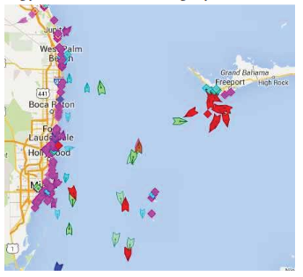
There are numerous ﬁlters and controls. The shape of the icons tell you whether the ship in in underway or anchored.
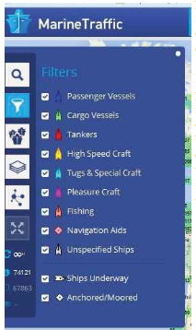
The color of the icon tells you what type of ship it is. Running your cursor over the icons will give you the name of the ship, the heading, speed, destination and age of the data. Left click on the icon to see bring up an information box with basic details of the ship along with a small image.

Inside that box is a button called 'Vessel Details' which will provide extensive information as well as one or more images of the ship.

